|  |
| --- |
| **National University of Computer and Emerging Sciences** |
| **Lab 5**  “Data Retrieval Select-from-where, Nested Queries” |
|  |
| **Database Systems Lab** |
| **Spring 2024** |

Department of Computer Science

FAST-NU, Lahore, Pakistan

**Schema:**

For this exercise use the following schema, the script to create this schema and populate data is given in Twitter.SQL file.

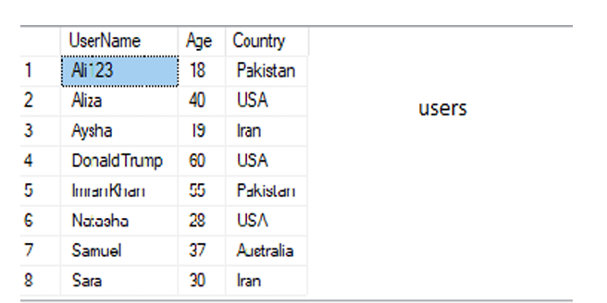

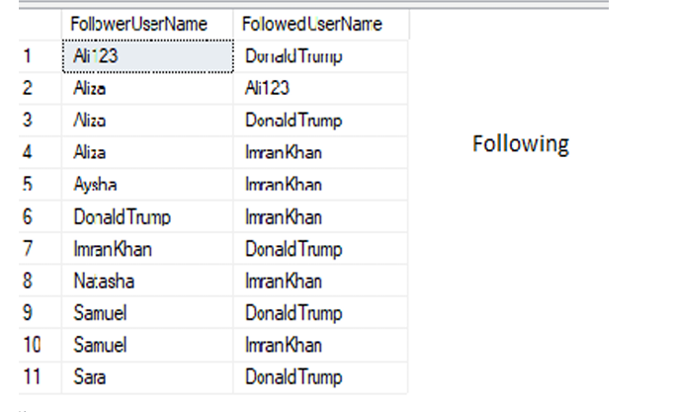

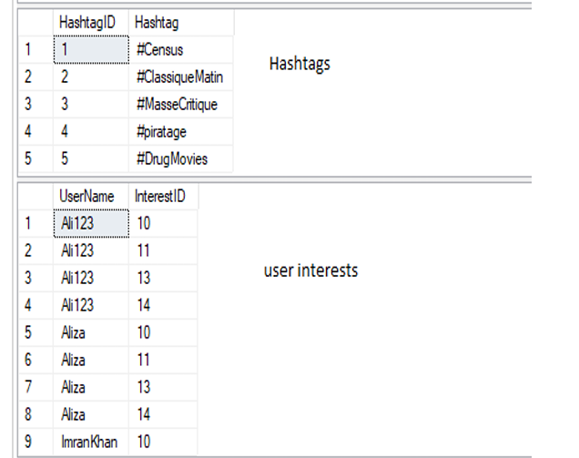

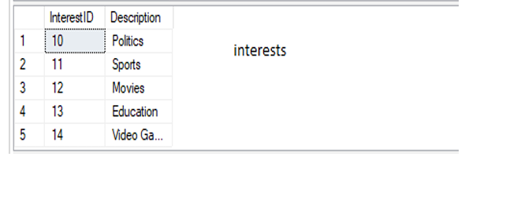

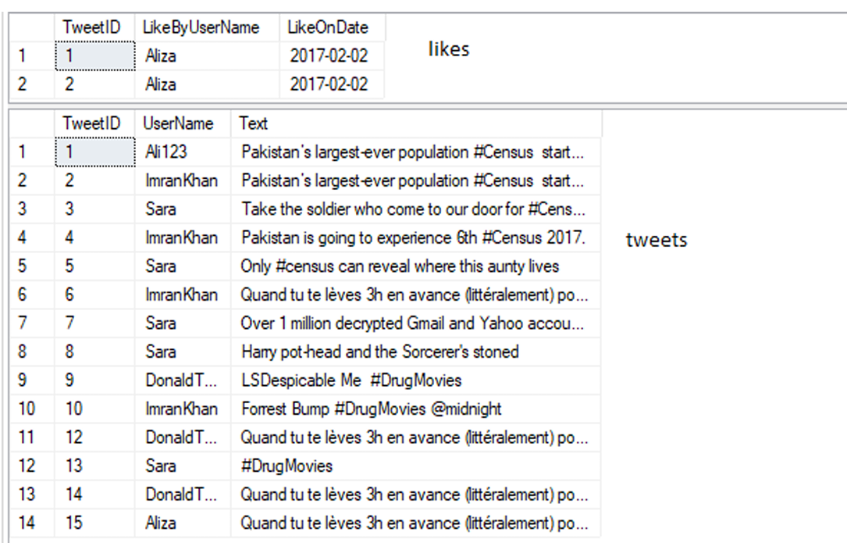

**Exercise:**

1. Find the tweets liked by users who are following 'ImranKhan'.
2. List the usernames of users who have interests in politics.
3. Get the usernames of users who have liked tweets by 'DonaldTrump'.
4. Find the tweets liked by users who have interests in both politics and sports.
5. List the usernames of users who are not following anyone
6. Retrieve the usernames of users who have liked tweets containing the hashtag '#MasseCritique'.
7. List the tweets liked by users who are from the USA.
8. Find the usernames of users who have interests in both movies and sports.
9. Retrieve the tweets liked by users who are following ‘Ali123’
10. List the usernames of users who have not liked any tweet.
11. Find the tweets liked by users who have interests in education